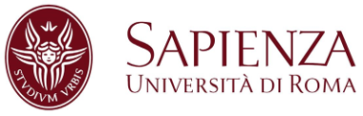

**EU FT-ICR MS 3rd Short Course**

***Ion-molecule reactions: fundamental and analytical aspects***

**Roma, June 25–27, 2019**

***Application Form***

**Personal information**

Last Name: First Name(s):

Gender:

Degree: BSc ____ MSc ____ PhD ___ Other ___

Email:

Telephone Number for EMERGENCY contact:

Home address (Street number / street name, Zip Code, Country):

Institution and administrative address (Lab name, Building, Postal address):

Institution Name:

*In the case that your application is validated, you will be required to send a copy of your passport / ID card.*

**Current position and research subject:**

Current position type: Graduate student / PhD student / Postdoctoral researcher / Researcher / Engineer – Technical staff member / Faculty

Short summary (5 lines ) of current and past research project(s):

Motivation for applying to this short course session (link between topic and current / future research projects; expectations from the short course session):

Current level of knowledge in mass spectrometry: Novice / Occasional User / Regular User / Expert

Date: ___ / ___ / _____ Signature: ________________________________________

Please, fill in, print, sign this application form and send a PDF copy before May 15th, 2019 to [mariaelisa.crestoni@uniroma1.it](mailto:mariaelisa.crestoni@uniroma1.it).

*The organizers will take charge of travel and accommodation expenses provided that all the required informations have been sent in due time.*