MilkQua – Milk Quality along the dairy chain
for a safe and sustainable milk
First Project Steering Board Meeting
June 3rd-4th, 2020
Press release

The MilkQua Project has hold its First project Steering Board Meeting on June 3rd and 4th afternoons, on a virtual meeting, in replacement of the initially planned meeting in Lodi (Italy). All partners were present. Twenty two participants were counted. After an introduction by Latifa Najar, coordinator (Idele), Mohamed Wageigh, project officer of PRIMA-IS gave feedback on the Synergy Meeting among projects in the agrofood sector on May 26th, 2020.
Latifa Najar reminded the project objectives along with implementation mainlines, project expected impacts and structure. She presented the state of implementation. The project is on very good tracks, with WP2-Innovative Quality Management Practices in Tunisa almost completed, WP3-In vitro evaluation of bioactive molecules and extracts largely advanced and WP8-Communication and dissemination having produced a lot of materials. Due to Covid-19 crisis, some delays have been reported on In Vivo experiments under WP3 that could lead to a slight delay of all interconnected project activities. Work Packages under implementation were presented in more details by WP leaders. Synergies and interactions activities around the assessement of antimicrobial effects of Essential Oils on both in vitro and in vivo studies were discussed, leading to the design of an ambition experimental action plan to be deployed in October 2020.
On June 4th afternoon, WPs that have not started were presented by WP leaders: WP5-System biology assessment of the effets of essential oils after in vitro and in vivo studies, WP6-Milk and dairy products processing and consumer studies, WP7-Consumer assessment of milk, followed by discussions. The end of the day was devoted to a presentation of achievements under WP8-Communication and Dissemination and discussions on ways to improve communication. Latifa Najar concluded the meeting with some slides about next steps. Partners wish they will be bale to meet next year in Tunisia to deepen exchanges.
All powerpoint presentations and recordings are available on the webpage: www.milkqua.eu/...
For more information about MilkQua: www.milkqua.eu

Project partners:
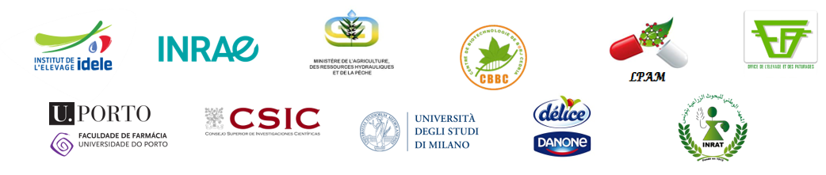

Event pages: https://www.facebook.com/616782781810081/posts/1680266685461680/ https://www.linkedin.com/posts/prima-secretariat_artisanefood-camelmilk-med4youth-activity-6672481854559399936-1q63 https://twitter.com/PRIMAInnovation/status/1266717356878974976?s=20

